Hampshire the Isle of Wight, Portsmouth and Southampton

Modern Slavery Partnership
Terms of Reference

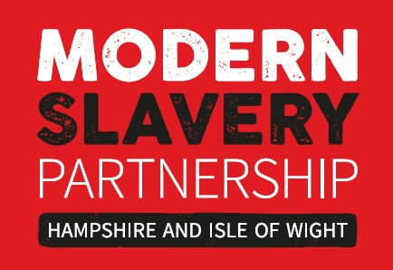

Background:

In November 2014 the Government produced its Modern Slavery Strategy setting out its approach by detailing the work expected from Government departments, agencies and partners in the UK and internationally, putting victims at the heart of the strategy, aligning its approach to the 4P framework – Pursue, Prevent, Protect and Prepare.

On 28 September 2015, the Hampshire, Isle of Wight, Portsmouth and Southampton Modern Slavery Partnership (MSP) was launched. The vision and strategic objectives are set out in the MSP Strategy 2017 – 2020. The vision of the partnership is to make Hampshire, the Isle of Wight, Portsmouth and Southampton a supportive place for victims and a hostile place for perpetrators of modern slavery. The Strategic Objectives are:

- To raise awareness of modern slavery
- To combat modern slavery by working in partnership
- To identify and support victims of modern slavery
- To pursue perpetrators of modern slavery

MSP Terms of Reference:

The purpose of the partnership is to coordinate delivery and monitor progress of the MSP Strategy 2017 - 2020. The MSP will have a clear agenda which will be aligned to the strategic objectives set out within the strategy. The actions associated with each strategic objective will have clear ownership and quarterly updates will be provided at the meeting to monitor ongoing progress.

- The MSP will meet quarterly and will be chaired and facilitated by the Office of the Police and Crime Commissioner (OPCC).

- Membership of the MSP will be open to partners who will proactively support the agreed vision and objectives. Members are critical to ensuring successful delivery of the strategy and thus will take a lead role within their organisation to positively promote the work of the MSP.

- The MSP will raise awareness of modern slavery, work in partnership and share good practice.

- The MSP will assist with the identification and support of victims and provide information and intelligence which supports the prosecution of perpetrators of modern slavery.

- Where funding is required to support delivery of the strategy the MSP will proactively support and seek suitable funding options.

- A separate multi-agency Pursue group, comprising primarily of law enforcement agencies, shall coordinate activity in relation to prosecuting and disrupting groups of individuals responsible for modern slavery. The chair of the Pursue group will act as a conduit between the MSP and Pursue group to ensure work strand are aligned and communication is optimised.

- Governance will be provided to the MSP from the Hampshire and Isle of Wight Police Local Criminal Justice Board (LCJB) which will be provided with an annual report outlining delivery against the strategy.

- The Modern Slavery Partnership Strategy and delivery structure will be reviewed in October 2020. In addition, the terms of reference and membership of the MSP will be reviewed annually by the OPCC to ensure they are supporting effective delivery of the strategy.

https://www.gov.uk/government/uploads/system/uploads/attachment_data/file/383764/Modern_Slavery_Strategy_FINAL_DEC2015.pdf

